# **BOOK COOK**

Real Time Problem: It’s difficult for many people to cook at home when they have to leave early or when they are busy with some other stuff. Some may not even know how to cook and its not healthy to eat outside everyday. The solution is BOOK COOK.

This app is for the foodies who love to have hot, delicious healthy food, cooked at their home from our qualified authentic chefs. All you need to do is download our app choose the menu and book. Our cook will come down to your home and cook the food in front of you. We also provide catering services for your housewarming, wedding functions, birthday parties and any other special occasions. We ensure taste as per your preference and quality at its best. Enjoy the day being at home and we are here to serve you

ABSTRACT

* + This application allows customers to book a slot, choose the menu with an estimated cost and place the order
  + The order can be for breakfast, lunch, dinner or for any other function
  + If its home cook service when the order is confirmed, allot the cook nearest to their location and share the required details between the customer and the cook
  + If its catering service when the order is confirmed allot the cook team is allocated and share the required details between the customer and the cook
  + Customer is provided with an option to buy the required ingredients or request delivery man to deliver the items.
  + The cook or cook team arrives and prepares the food.
  + The payment can be made online or by cash.
  + The customer gives the feedback of the service.

ASSUMPTIONS/EXCEPTIONS

HOME COOK SERVICE

* + The required utensils are available at customers home
  + The number of serves should not exceed 10
  + Chefs are not responsible for cleaning
  + Customer cannot change the menu once the cook has arrived but still, we do consider minor modifications to give you the best service.

CATERING SERVICE

* + The required utensils are brought by the cook team
  + Cleaning is done by a separate set of people

FEATURES

REGISTRATION: The customers have to get registered via valid email-id and phone number.

LOCATION ACCESS: The customer has to select current location or can book for any other location.

MENU: The customer can search for their favourite dishes and select the appropriate option

ESTIMATION CALCULATION: The estimation of price for the service provided that includes cooking charge, conveyance charge, delivery of items and tax is given so that customer gets an idea about the price value he has to pay.

TRACKING: Once the booking is confirmed the details of the cook and delivery man like name, vehicle number are shared with the customer and he can track them with the help of app.

PAYMENT GATEWAY: The customer can pay online using secured gateways, standard online wallets or by cash

FEEDBACK: The customers can submit the feedback and suggestions if there is any need for improvement

EMERGENCY BUTTON: Safety is first priority for both customers and foodie buddy servicemen So, an emergency button is provided so that the person in danger presses it in case of any danger.

**TARGET MARKET SIZE FOR BOOK COOK**

The size of the market with respect to India:

The population of India is estimated to be 1.37 billion based on most recent UN data among which 300 million people are using smart phones. The data base says that in India there are about 161.8 million users using the online food order facilities like swiggy, zomato etc. Therefore the remaining is about 138.2 million. Therefore the market size is total number of smart phones users.

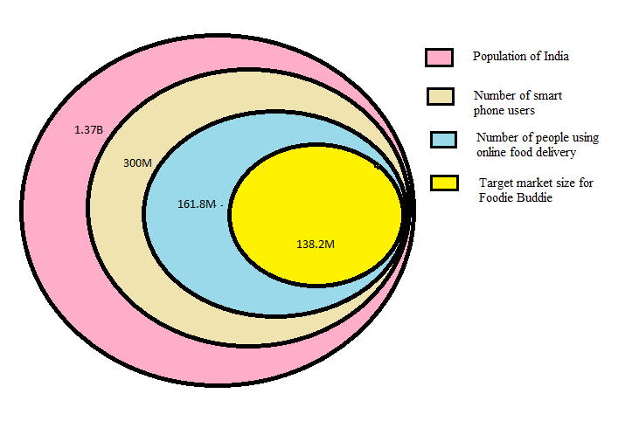

Fig: Graphical representation of Target market size

REFERENCES:

Stastista-The Statics Portal for Market Data